EMBEDDED SYSTEM WITH IOT
EXPERIMENT NO. 6

IOT-BASED BUILDING SYSTEM

Name: Raphael S. Nano

Course/Section: CPE162P / C1

Date of Performance: April 1-3, 2024
Date of Submission: April 4, 2024

Ma'am Cyrel Manlises
Instructor

DISCUSSION

It is undeniable that buildings utilize several components in accommodating the people that use rooms and the lights within those rooms. Managers and the like always think of ways in order to control the energy being used by the occupants or users, especially with regards to the usage of light bulbs. Because of this, several IoT-based systems are being developed, wherein light bulbs only turn on when people are present within a room, or the system is only activated if the people inside reach a certain minimum or limit. In consideration with that, an IoT-based Building System was constructed and developed using ultrasonic distance sensors, LCD, LEDs, and ESP8266 that serves as the microcontroller of the system.

For experiment 6, the objectives are as follows:
1. To demonstrate how an IoT-based Building System works.
2. To be able apply what you have learned in logic circuits and switching theory, microprocessors, CPE160P, and CPE161P.
3. To be able to apply embedded system with IoT using Arduino kit
4. To be able to use ThingSpeak for the data collection and analysis.

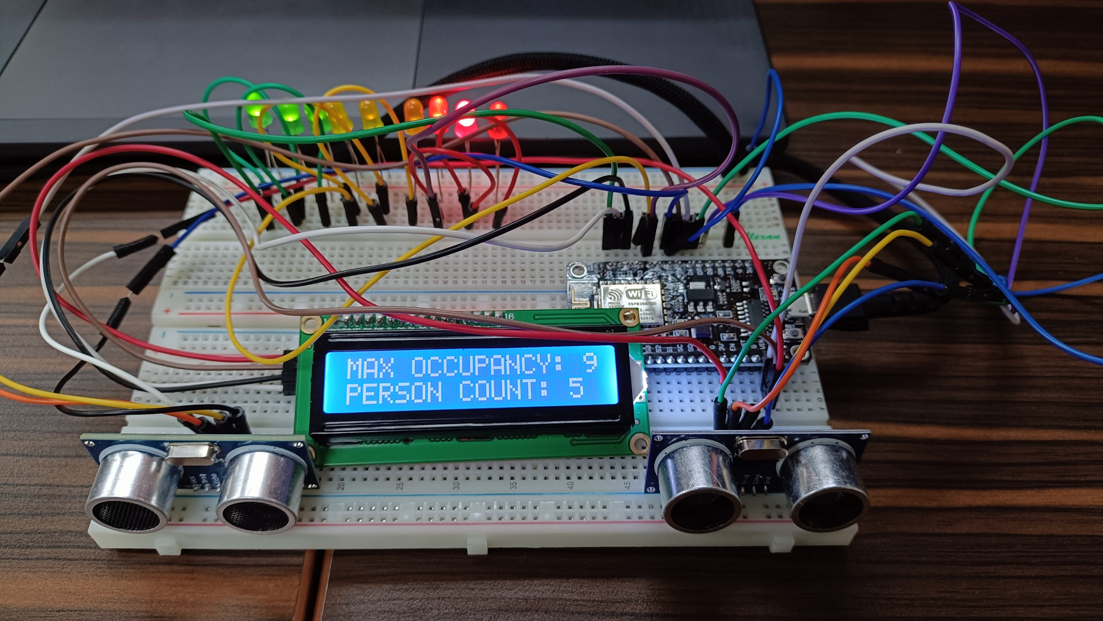
The materials involved in constructing the IoT-based Irrigation System are the ESP8266 WiFi module, 2 HC-SR04 Ultrasonic Distance Sensors, liquid crystal display, and LEDs.

Figure 1. Main Circuit for the Experiment

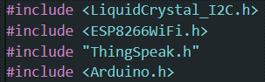
The external libraries include ESP8266WiFi.h and ThingSpeak.h. The LCD used LiquidCrystal_I2C.h.

Figure 2. External Libraries Included

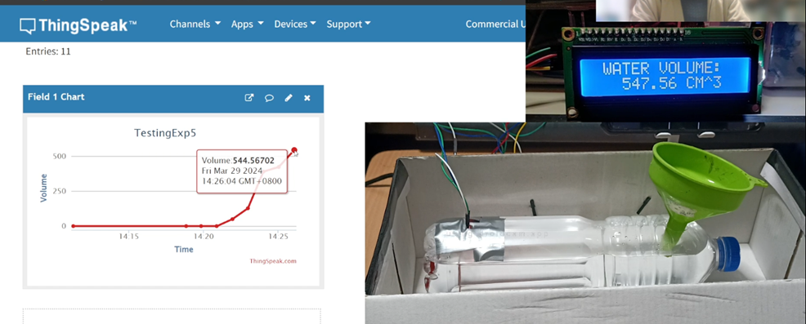
The main objective of experiment 6 is to control the light usage in a specific meeting room, wherein lights will be lit up with increasing intensity based on the number of people that entered. ThingSpeak displays the number of occupants in a specific time and the status of light if it is ON or OFF.

Figure 3. Sample Output of Experiment 6
The primary features of this system are the detection of the ultrasonic distance sensors and the outputs of the LCD and LEDs based on how many people passed the entry point. There are two ultrasonic distance sensors (USDs): one for entry and one for exit. To trigger the USD, the pins assigned to each TRIG will be set to HIGH and a pulse will be received by the ECHO pins.
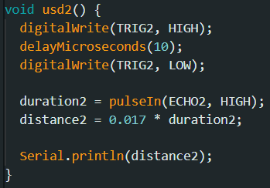
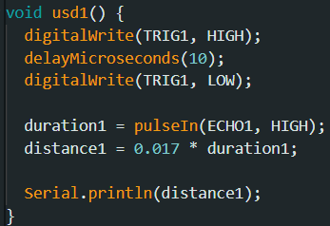

Figure 4. USD Functions

After detecting the distance using usd1() and usd2(), the system would then display the number of occupants in the building or room using lcd.print(). The max occupancy and current number of occupants are continuously displayed in the system.

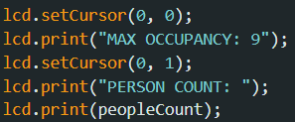

Figure 5. LCD Functions

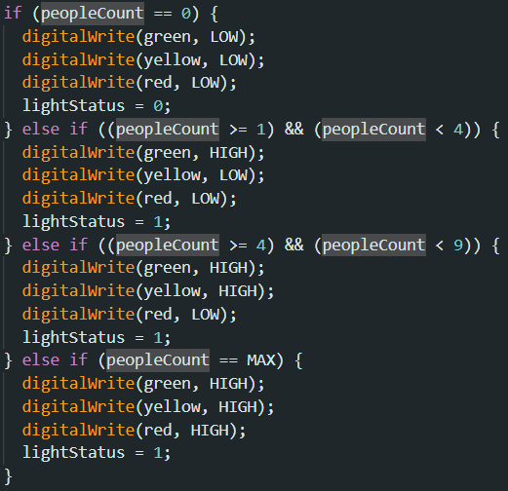
For the LEDs, conditions were set, wherein if there are no people detected, all LEDs are OFF. If there are 1 to 4 people inside, then the green LEDs will be turned ON, signifying the intensity and number of lights based on number of people. If 5 to 8 people comes in, the yellow LEDs will be activated, depicting that there are more people. Lastly, if the occupancy is at maximum, which is 9 people, the red LEDs will be turned ON, showing that the room is full.

Figure 6. LEDs Functions
The same code was utilized in establishing the Wi-Fi connection. It provides information to the user via the Serial Monitor, indicating the status of the connection attempt.
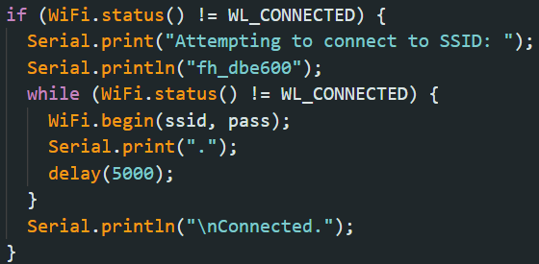

Figure 7. WiFi Function

ThingSpeak updates its fields every 1 minute. In this situation, two fields are being updated every time, which are the occupancy count and status of the light (if ON/1 or OFF/0).
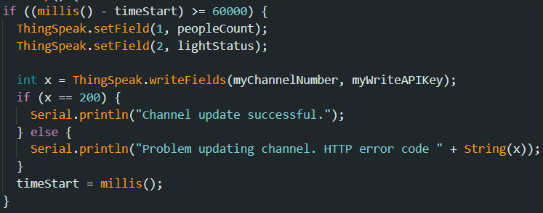

Figure 8. Thingspeak Function

RESULTS
The IoT-based Building System was tested for four conditions: (1) No people, (2) 1-4 occupants, (3) 5-8 occupants, and (4) 9 occupants, the max number of people. For no people, no lights are turned ON. The LCD also specified that the person count is at 0. Moreover, the ThingSpeak accurately outputs the number of occupants, which is 0, and the status of the lights, which is OFF (0). If the exit sensor detects something despite no one in the room, a prompt shows that nine spaces are available.
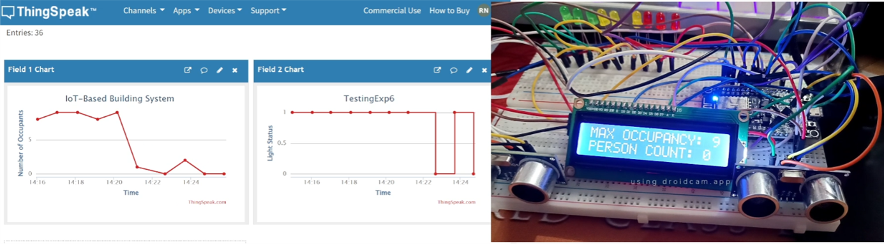

Figure 9. No People

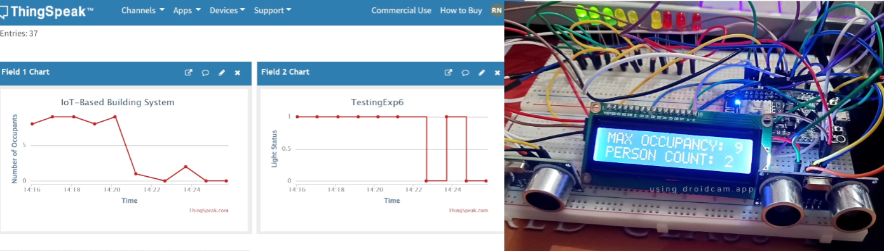
The next part is when there come occupants in the room through the entry ultrasonic distance sensor. The LCD outputs the person count as it increments one by one. With 1 - 4 people present, three green lights are turned ON. ThingSpeak also displays the number of occupants accordingly.
The status of the light is now 1 or ON since there are people inside the room.

Figure 10. 1-4 Occupants

For 5-8 people, three yellow LEDs are added to the ON status. The person count in the LCD and the number of occupants in ThingSpeak also displayed the values correspondingly as more people enter the room. Moreover, if the ultrasonic distance sensor for exit detects motion, the numbers mentioned above decreases one by one, correspondingly.

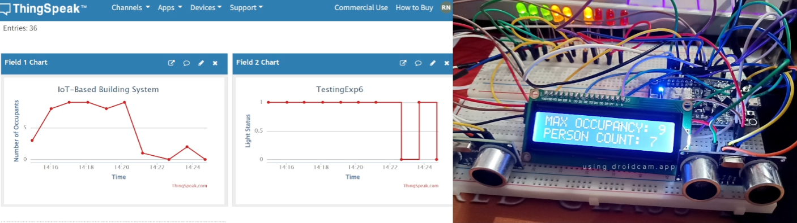

Figure 11. 5-8 Occupants

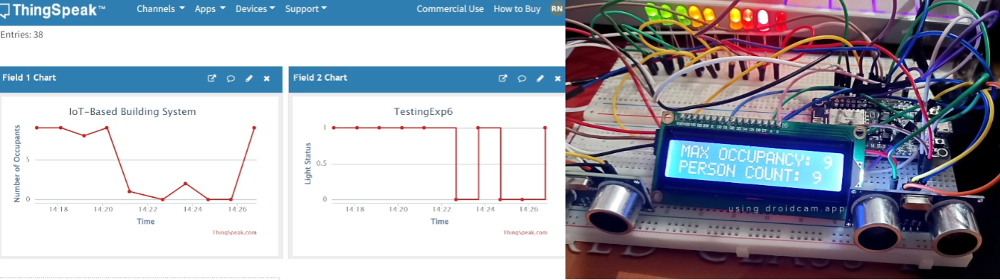
Lastly, at the maximum level of 9 occupants, the red LEDs are now ON and all of the LEDs are ON, which signifies the number of people inside the room or building. ThingSpeak also shows the number of people, which is 9, and the LCD shows 9 in the person count as well. If people try to enter through the sensor again, a prompt shows that the maximum occupancy has been reached.

Figure 12. 9 Occupants (Max)

CONCLUSION
To conclude the experiment, the IoT-based Building System employs several functions in order to fully display the process. Usd1() and usd2() were created to activate the ultrasonic distance sensors, and when they detect an object, the entry sensor will increment the number of occupants, whereas the exit sensor will decrement it. The LCD simply prints the max occupancy and the current person count, and the LEDs were successfully turned ON based on ranges 0, 1-4, 5-8, and 9. To fulfill the second goal, the CPE160P and CPE161P courses were particularly implemented by connecting the ESP8266 to ThingSpeak using Arduino IDE codes and synchronizing the ultrasonic distance sensor inputs with the outputs in the LCD and LEDs. Also, ThingSpeak implementation was accurate, since it regularly broadcasts the number of occupants and light status every minute. Therefore, the IoT-based Building System was successfully developed, with accurate sensor readings and clear LCD and LED outputs.

